***University Physics Volume II***

**Unit 2: Electricity and Magnetism**

**Chapter 6: Gauss’s Law**

**Conceptual Questions**

1. Discuss how to orient a planar surface of area *A* in a uniform electric field of magnitude  to obtain (a) the maximum flux and (b) the minimum flux through the area.

Solution

a. If the planar surface is perpendicular to the electric field vector, the maximum flux would be obtained. b. If the planar surface were parallel to the electric field vector, the minimum flux would be obtained.

1. What are the maximum and minimum values of the flux in the preceding question?

Solution

maximum  minimum 

1. The net electric flux crossing a closed surface is always zero. True or false?

Solution

False. The net electric flux crossing a closed surface is always zero if and only if the net charge enclosed is zero.

1. The net electric flux crossing an open surface is never zero. True or false?

Solution

False. Consider a region of uniform electric field with an open surface that is U shaped. If the flat parts of the U are perpendicular to the electric field, the net flux is zero.

1. Two concentric spherical surfaces enclose a point charge *q*. The radius of the outer sphere is twice that of the inner one. Compare the electric fluxes crossing the two surfaces.

Solution

Since the electric field vector has a dependence, the fluxes are the same since .

1. Compare the electric flux through the surface of a cube of side length *a* that has a charge *q* at its center to the flux through a spherical surface of radius *a* with a charge *q* at its center.

Solution

Both are .

1. (a) If the electric flux through a closed surface is zero, is the electric field necessarily zero at all points on the surface? (b) What is the net charge inside the surface?

Solution

a. no; b. zero

1. Discuss how Gauss’s law would be affected if the electric field of a point charge did not vary as 

Solution

Gauss’s law would have some dependence on *r* and this would violate conservation of flux.

1. Discuss the similarities and differences between the gravitational field of a point mass *m* and the electric field of a point charge *q*.

Solution

Both fields vary as . Because the gravitational constant is so much smaller than , the gravitational field is orders of magnitude weaker than the electric field. Also, the gravitational flux through a closed surface is zero or positive; however, the electric flux is positive, negative, or zero, depending on the definition of flux for the given situation.

1. Discuss whether Gauss’s law can be applied to other forces, and if so, which ones.

Solution

Gauss’s law can be applied to Newton’s universal law of gravitation, since both are inverse square forces. The law cannot be applied to nonconservative forces, such as friction, tension, or air resistance.

1. Is the term  in Gauss’s law the electric field produced by just the charge inside the Gaussian surface?

Solution

No, it is produced by all charges both inside and outside the Gaussian surface.

1. Reformulate Gauss’s law by choosing the unit normal of the Gaussian surface to be the one directed inward.

Solution

In the below figure, replace the positive charge at the center with a negative charge. Then the electric field would point inward and in the opposite direction of the unit normal. The minus sign would come out after the dot product of the electric field and the unit normal, leaving

.

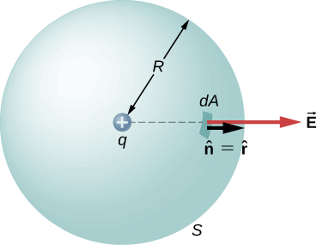

1. Would Gauss’s law be helpful for determining the electric field of two equal but opposite charges a fixed distance apart?

Solution

No, since the situation does not have symmetry, making Gauss’s law challenging to simplify.

1. Discuss the role that symmetry plays in the application of Gauss’s law. Give examples of continuous charge distributions in which Gauss’s law is useful and not useful in determining the electric field.

Solution

Gauss’s law is useful in determining the electric field in and around continuous charge distributions on spheres, concentric spherical shells, cylinders, concentric cylindrical shells, and solid and concentric geometrical objects such as cubes. Gauss’s law is not useful when the charge distribution is not continuous. If the charge density is different on opposite sides of a geometrical object, there is no symmetry and Gauss’s law should not be used.

1. Discuss the restrictions on the Gaussian surface used to discuss planar symmetry. For example, is its length important? Does the cross-section have to be square? Must the end faces be on opposite sides of the sheet?

Solution

Any shape of the Gaussian surface can be used. The only restriction is that the Gaussian integral must be calculable; therefore, a box or a cylinder are the most convenient geometrical shapes for the Gaussian surface.

1. Is the electric ﬁeld inside a metal always zero?

Solution

The answer is no. The argument for the vanishing of the electric ﬁeld inside a metal required static conditions on the conduction electrons. When a metal wire carries current the conduction electrons are not static. Therefore, the electric ﬁeld will not be zero inside a metal in which conduction electrons are not static. Therefore, often- quoted simplistic rule that, “the electric ﬁeld inside a conductor is zero,” applies only to static situations. If electric ﬁeld were zero in all situations, then there will be no electric current in a metal wire. We will ﬁnd that the conduction of electricity requires non-zero electric ﬁeld inside a conductor.

1. Under electrostatic conditions, the excess charge on a conductor resides on its surface. Does this mean that all the conduction electrons in a conductor are on the surface?

Solution

No. If a metal was in a region of zero electric field, all the conduction electrons would be distributed uniformly throughout the metal.

1. A charge *q* is placed in the cavity of a conductor as shown below. Will a charge outside the conductor experience an electric field due to the presence of *q*?

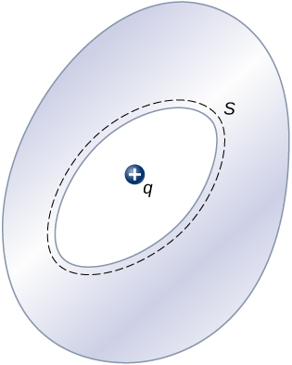

Solution

Yes, a charge +*q* is induced on the outside surface, generating an electric field external to the conductor.

1. The conductor in the preceding figure has an excess charge of . If a  point charge is placed in the cavity, what is the net charge on the surface of the cavity and on the outer surface of the conductor?

Solution

Since the electric field is zero inside a conductor, a charge of  is induced on the inside surface of the cavity. This will put a charge of  on the outside surface leaving a net charge of  on the surface.

**Problems**

1. A uniform electric field of magnitude  is perpendicular to a square sheet with sides 2.0 m long. What is the electric flux through the sheet?

Solution



1. Calculate the flux through the sheet of the previous problem if the plane of the sheet is at an angle of  to the field. Find the flux for both directions of the unit normal to the sheet.

Solution

 electric field in direction of unit normal;  electric field opposite to unit normal

1. Find the electric ﬂux through a rectangular area  between two parallel plates where there is a constant electric ﬁeld of 30 N/C for the following orientations of the area: (a) parallel to the plates, (b) perpendicular to the plates, and (c) the normal to the area making a  angle with the direction of the electric ﬁeld. Note that this angle can also be given as 

Solution

a. ; b. ; c. 

1. The electric ﬂux through a square-shaped area of side 5 cm near a large charged sheet is found to be  when the area is parallel to the plate. Find the charge density on the sheet.

Solution



1. Two large rectangular aluminum plates of area  face each other with a separation of 3 mm between them. The plates are charged with equal amount of opposite charges, . The charges on the plates face each other. Find the ﬂux through a circle of radius 3 cm between the plates when the normal to the circle makes an angle of  with a line perpendicular to the plates. Note that this angle can also be given as 

Solution

;  if the electric field is in the same direction of the area normal. If , then .

1. A square surface of area  is in a space of uniform electric ﬁeld of magnitude . The amount of ﬂux through it depends on how the square is oriented relative to the direction of the electric ﬁeld. Find the electric ﬂux through the square, when the normal to it makes the following angles with electric ﬁeld: (a) **, (b) , and (c) . Note that these angles can also be given as **.

Solution

a. ;

b. ; c. 

1. A vector ﬁeld is pointed along the *z*-axis,  (a) Find the ﬂux of the vector ﬁeld through a rectangle in the *xy*-plane between ** and **. (b) Do the same through a rectangle in the *yz*-plane between ** and **. (Leave your answer as an integral.)

Solution

a. ;

b. 

1. Consider the uniform electric field  What is its electric flux through a circular area of radius 2.0 m that lies in the *xy*-plane?

Solution





1. Repeat the previous problem, given that the circular area is (a) in the *yz*-plane and (b) above the *xy-*plane.

Solution

a. ; b. The normal to the circular area is put at 45 degrees to the *xy*-plane:  

1. An infinite charged wire with charge per unit length  lies along the central axis of a cylindrical surface of radius *r* and length *l*. What is the flux through the surface due to the electric field of the charged wire?

Solution



1. Determine the electric flux through each closed surface where the cross-section inside the surface is shown below.

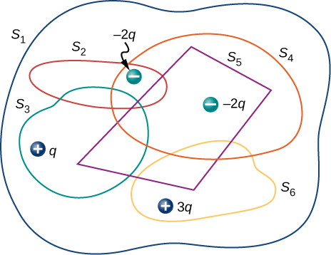

Solution





1. Find the electric flux through the closed surface whose cross-sections are shown below.

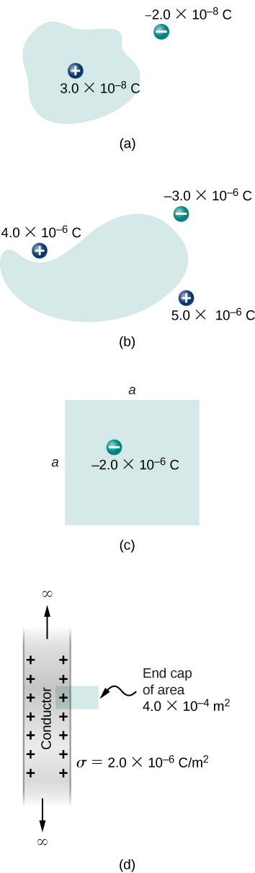

Solution

a. ; b. ;

c. ;

d. 

1. A point charge *q* is located at the center of a cube whose sides are of length *a*. If there are no other charges in this system, what is the electric flux through one face of the cube?

Solution

 because the flux is divided equally among the six sides

1. A point charge of  is at an unspecified location inside a cube of side 2 cm. Find the net electric ﬂux though the surfaces of the cube.

Solution



1. A net ﬂux of  passes inward through the surface of a sphere of radius 5 cm. (a) How much charge is inside the sphere? (b) How precisely can we determine the location of the charge from this information?

Solution

a. ;

b. anywhere inside the sphere

1. A charge *q* is placed at one of the corners of a cube of side *a*, as shown below. Find the magnitude of the electric ﬂux through the shaded face due to *q*. Assume .

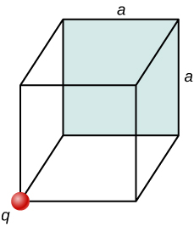

Solution

Make a cube with *q* at the center, using the cube of side *a*. This would take four cubes of side *a* to make one side of the large cube. The shaded side of the small cube would be 1/24th of the total area of the large cube; therefore, the flux through the shaded area would be .

1. The electric flux through a cubical box 8.0 cm on a side is What is the total charge enclosed by the box?

Solution



1. The electric flux through a spherical surface is  What is the net charge enclosed by the surface?

Solution



1. A cube whose sides are of length *d* is placed in a uniform electric field of magnitude  so that the field is perpendicular to two opposite faces of the cube. What is the net flux through the cube?

Solution

zero, since flux in equals flux out

1. Repeat the previous problem, assuming that the electric field is directed along a body diagonal of the cube.

Solution

zero, also because flux in equals flux out

1. A total charge  is distributed uniformly throughout a cubical volume whose edges are 8.0 cm long. (a) What is the charge density in the cube? (b) What is the electric flux through a cube with 12.0-cm edges that is concentric with the charge distribution? (c) Do the same calculation for cubes whose edges are 10.0 cm long and 5.0 cm long. (d) What is the electric flux through a spherical surface of radius 3.0 cm that is also concentric with the charge distribution?

Solution

a. ; b. ; c. The same flux for the 10-cm long cube. The fraction of charge enclosed for the 5-cm long cube is ;

d. 

1. Recall that in the example of a uniform charged sphere,  Rewrite the answers in terms of the total charge *Q* on the sphere.

Solution



1. Suppose that the charge density of the spherical charge distribution shown in the following figure is  for  and zero for  Obtain expressions for the electric field both inside and outside the distribution.

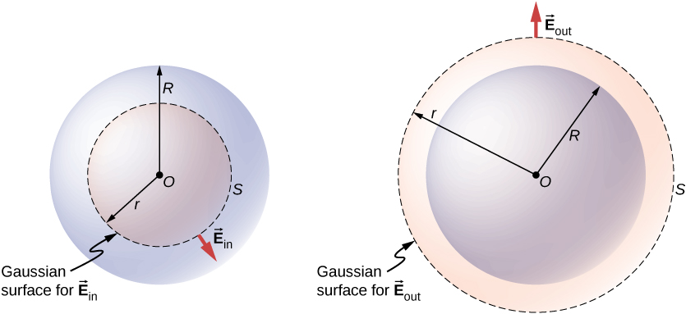

Solution

  for  for 

1. A very long, thin wire has a uniform linear charge density of  What is the electric field at a distance 2.0 cm from the wire?

Solution



1. A charge of  is distributed uniformly throughout a spherical volume of radius 10.0 cm. Determine the electric field due to this charge at a distance of (a) 2.0 cm, (b) 5.0 cm, and (c) 20.0 cm from the center of the sphere.

Solution

a. ;

b. ;

c. 

1. Repeat your calculations for the preceding problem, given that the charge is distributed uniformly over the surface of a spherical conductor of radius 10.0 cm.

Solution

a. 0; b. 0; c. 

1. A total charge *Q* is distributed uniformly throughout a spherical shell of inner and outer radii  respectively. Show that the electric field due to the charge is



Solution

a. ; b. ,

; The electric field is directed outward.

c.; The electric field is directed outward.

1. When a charge is placed on a metal sphere, it ends up in equilibrium at the outer surface. Use this information to determine the electric ﬁeld of  charge put on a 5.0-cm aluminum spherical ball at the following two points in space: (a) a point 1.0 cm from the center of the ball (an inside point) and (b) a point 10 cm from the center of the ball (an outside point).

Solution

a. 0; b. 

1. A large sheet of charge has a uniform charge density of  What is the electric field due to this charge at a point just above the surface of the sheet?

Solution



1. Determine if approximate cylindrical symmetry holds for the following situations. State why or why not. (a) A 300-cm long copper rod of radius 1 cm is charged with +500 nC of charge and we seek electric ﬁeld at a point 5 cm from the center of the rod. (b) A 10-cm long copper rod of radius 1 cm is charged with +500 nC of charge and we seek electric ﬁeld at a point 5 cm from the center of the rod. (c) A 150-cm wooden rod is glued to a 150-cm plastic rod to make a 300-cm long rod, which is then painted with a charged paint so that one obtains a uniform charge density. The radius of each rod is 1 cm, and we seek an electric ﬁeld at a point that is 4 cm from the center of the rod. (d) Same rod as (c), but we seek electric ﬁeld at a point that is 500 cm from the center of the rod.

Solution

a. Yes, the length of the rod is much greater than the distance to the point in question. b. No, The length of the rod is of the same order of magnitude as the distance to the point in question. c. Yes, the length of the rod is much greater than the distance to the point in question. d. No. The length of the rod is of the same order of magnitude as the distance to the point in question.

1. A long silver rod of radius 3 cm has a charge of  on its surface. (a) Find the electric ﬁeld at a point 5 cm from the center of the rod (an outside point). (b) Find the electric ﬁeld at a point 2 cm from the center of the rod (an inside point)

Solution

a. ,

; b. 0

1. The electric ﬁeld at 2 cm from the center of long copper rod of radius 1 cm has a magnitude 3 N/C and directed outward from the axis of the rod. (a) How much charge per unit length exists on the copper rod? (b) What would be the electric ﬂux through a cube of side 5 cm situated such that the rod passes through opposite sides of the cube perpendicularly?

Solution

a. ,

;

b. 

1. A long copper cylindrical shell of inner radius 2 cm and outer radius 3 cm surrounds concentrically a charged long aluminum rod of radius 1 cm with a charge density of 4 pC/m. All charges on the aluminum rod reside at its surface. The inner surface of the copper shell has exactly opposite charge to that of the aluminum rod while the outer surface of the copper shell has the same charge as the aluminum rod. Find the magnitude and direction of the electric ﬁeld at points that are at the following distances from the center of the aluminum rod: (a) 0*.*5 cm, (b) 1*.*5 cm, (c) 2*.*5 cm, (d) 3*.*5 cm, and (e) 7 cm.

Solution

a. 0; b. ,

 directed outward; c. 0;

d. , ;

e. 

1. Charge is distributed uniformly with a density  throughout an infinitely long cylindrical volume of radius *R*. Show that the field of this charge distribution is directed radially with respect to the cylinder and that



Solution

; 

1. Charge is distributed throughout a very long cylindrical volume of radius *R* such that the charge density increases with the distance *r* from the central axis of the cylinder according to  where  is a constant. Show that the field of this charge distribution is directed radially with respect to the cylinder and that



Solution

,

,



1. The electric field 10.0 cm from the surface of a copper ball of radius 5.0 cm is directed toward the ball’s center and has magnitude  How much charge is on the surface of the ball?

Solution



1. Charge is distributed throughout a spherical shell of inner radius  and outer radius  with a volume density given by  where  is a constant. Determine the electric field due to this charge as a function of *r*, the distance from the center of the shell.

Solution

, ,

,



1. Charge is distributed throughout a spherical volume of radius *R* with a density where  is a constant. Determine the electric field due to the charge at points both inside and outside the sphere.

Solution

,

,



1. Consider a uranium nucleus to be sphere of radius  with a charge of 92*e* distributed uniformly throughout its volume. (a) What is the electric force exerted on an electron when it is  from the center of the nucleus? (b) What is the acceleration of the electron at this point?

Solution

a. ,

,

;

b. 

1. The volume charge density of a spherical charge distribution is given by  where  and  are constants. What is the electric field produced by this charge distribution?

Solution

integrate by parts: 



1. An uncharged conductor with an internal cavity is shown in the following figure. Use the closed surface *S* along with Gauss’ law to show that when a charge *q* is placed in the cavity a total charge –*q* is induced on the inner surface of the conductor. What is the charge on the outer surface of the conductor?

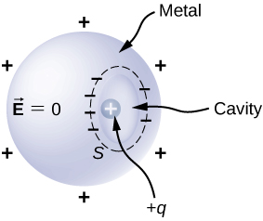

Solution

; Since the electric field at the Gaussian surface is inside the conductor it must be zero; therefore,  is induced on the inside surface of the cavity. Put a Gaussian surface outside the conductor. Since the conductor was initially uncharged the enclosed charge is *q*, so there must be a charge of ** on the outside surface.

1. An uncharged spherical conductor *S* of radius *R* has two spherical cavities A and B of radii *a* and *b*,respectively as shown below. Two point charges  and  are placed at the center of the two cavities by using non-conducting supports. In addition, a point charge  is placed outside at a distance *r* from the center of the sphere. (a) Draw approximate charge distributions in the metal although metal sphere has no net charge. (b) Draw electric ﬁeld lines. Draw enough lines to represent all distinctly different places.

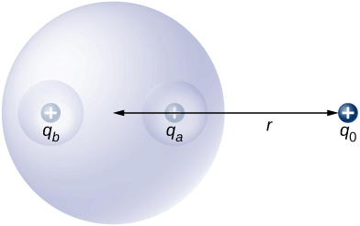

Solution

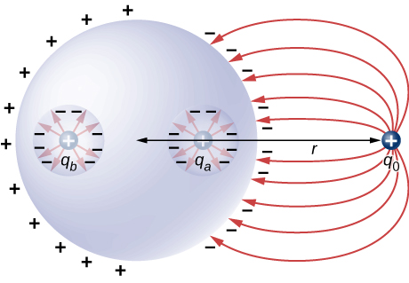

1. A positive point charge is placed at the angle bisector of two uncharged plane conductors that make an angle of  See below. Draw the electric ﬁeld lines.

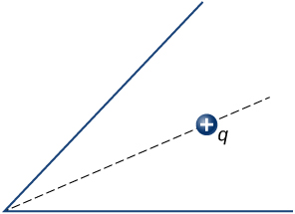

Solution

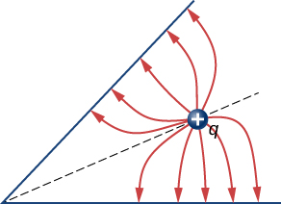

1. A long cylinder of copper of radius 3 cm is charged so that it has a uniform charge per unit length on its surface of 3 C/m. (a) Find the electric ﬁeld inside and outside the cylinder. (b) Draw electric ﬁeld lines in a plane perpendicular to the rod.

Solution

a. Outside: ; Inside ; b.

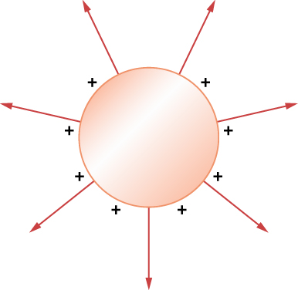

1. An aluminum spherical ball of radius 4 cm is charged with  of charge. A copper spherical shell of inner radius 6 cm and outer radius 8 cm surrounds it. A total charge of  is put on the copper shell. (a) Find the electric ﬁeld at all points in space, including points inside the aluminum and copper shell when copper shell and aluminum sphere are concentric. (b) Find the electric ﬁeld at all points in space, including points inside the aluminum and copper shell when the centers of copper shell and aluminum sphere are 1 cm apart.

Solution

a. , ,

,

; b. Put the center of the copper shell at the origin, then  same as (a); , any point between the sphere and shell  where  is the radial distance to the point as measured from the center of the sphere. Inside the sphere .

1. A long cylinder of aluminum of radius *R* meters is charged so that it has a uniform charge per unit length on its surface of **. (a) Find the electric ﬁeld inside and outside the cylinder. (b) Plot electric ﬁeld as a function of distance from the center of the rod.

Solution

a.  *E* inside equals 0; b.

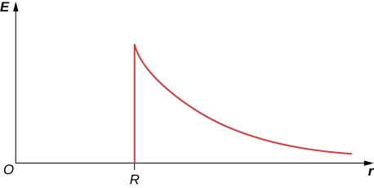

1. At the surface of any conductor in electrostatic equilibrium,  Show that this equation is consistent with the fact that  at the surface of a spherical conductor.

Solution



1. Two parallel plates 10 cm on a side are given equal and opposite charges of magnitude  The plates are 1.5 mm apart. What is the electric field at the center of the region between the plates?

Solution



1. Two parallel conducting plates, each of cross-sectional area , are 2.0 cm apart and uncharged. If  electrons are transferred from one plate to the other, what are (a) the charge density on each plate? (b) The electric field between the plates?

Solution

a. ;

b.

1. The surface charge density on a long straight metallic pipe is . What is the electric field outside and inside the pipe? Assume the pipe has a diameter of 2*a*.

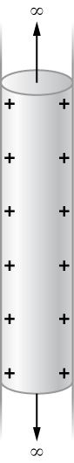

Solution

,  inside since 

1. A point charge  is placed at the center of a spherical conducting shell of inner radius 3.5 cm and outer radius 4.0 cm. The electric field just above the surface of the conductor is directed radially outward and has magnitude 8.0 N/C. (a) What is the charge density on the inner surface of the shell? (b) What is the charge density on the outer surface of the shell? (c) What is the net charge on the conductor?

Solution

a. ;

b. ; c. 

1. A solid cylindrical conductor of radius *a* is surrounded by a concentric cylindrical shell of inner radius *b*. The solid cylinder and the shell carry charges +*Q* and –*Q*, respectively. Assuming that the length *L* of both conductors is much greater than *a* or *b*, determine the electric field as a function of *r*, the distance from the common central axis of the cylinders, for (a)  (b)  and (c)

Solution

a. ; b. ; c.  since *r* would be either inside the second shell or if outside then *q* enclosed equals 0.

**Additional Problems**

1. A vector field  (not necessarily an electric field; note units) is given by  Calculate  where *S* is the area shown below. Assume that 

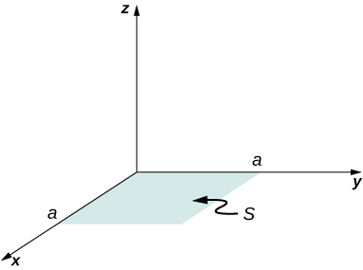

Solution



1. Repeat the preceding problem, with 

Solution



1. A circular area *S* is concentric with the origin, has radius *a*, and lies in the *yz*-plane. Calculate  for 

Solution



1. (a) Calculate the electric flux through the open hemispherical surface due to the electric field  (see below). (b) If the hemisphere is rotated by  around the *x*-axis, what is the flux through it?

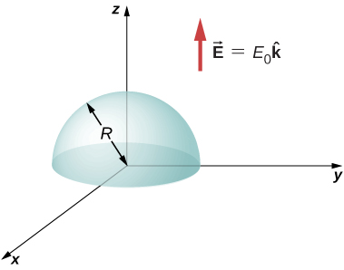

Solution

a. 

; b. zero, since the flux through the upper half cancels the flux through the lower half of the sphere

1. Suppose that the electric field of an isolated point charge were proportional to  rather than  Determine the flux that passes through the surface of a sphere of radius *R* centered at the charge. Would Gauss’s law remain valid?

Solution

; No, since the flux would depend on the radius of the sphere, which violates the continuity of flux.

1. The electric field in a region is given by  where   and  What is the net charge enclosed by the shaded volume shown below?

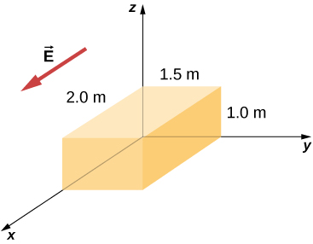

Solution

; There are two contributions to the surface integral: one at the side of the rectangle at  and the other at the side at ;



where the minus sign indicates that at , the electric field is along positive *x* and the unit normal is along negative *x*. At , the unit normal and the electric field vector are in the same direction: .

1. Two equal and opposite charges of magnitude *Q* are located on the *x*-axis at the points +*a* and –*a*, as shown below. What is the net flux due to these charges through a square surface of side 2*a* that lies in the *yz*-plane and is centered at the origin? (*Hint:* Determine the flux due to each charge separately, then use the principle of superposition. You may be able to make a symmetry argument.)

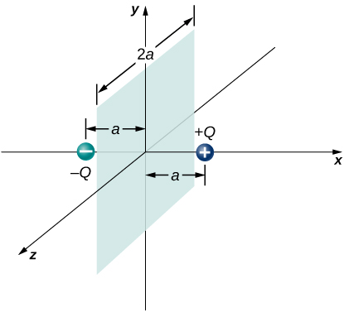

Solution

Make a cube around the positive charge. The flux through one side is

. The flux due to the negative charge is the same, so total flux is 

1. A fellow student calculated the flux through the square for the system in the preceding problem and got 0. What went wrong?

Solution

didn’t keep consistent directions for the area vectors, or the electric fields

1. A  piece of aluminum foil of 0*.*1 mm thickness has a charge of  that spreads on both wide side surfaces evenly. You may ignore the charges on the thin sides of the edges. (a) Find the charge density. (b) Find the electric ﬁeld 1 cm from the center, assuming approximate planar symmetry.

Solution

a. ; b.  from each side: 

1. Two pieces of aluminum foil of thickness 0*.*1 mm face each other with a separation of 5 mm. One of the foils has a charge of  and the other has . (a) Find the charge density at all surfaces, i.e., on those facing each other and those facing away. (b) Find the electric ﬁeld between the plates near the center assuming planar symmetry.

Solution

a. ,  on one and  on the other; b. 

1. Two large copper plates facing each other have charge densities  on the surface facing the other plate, and zero in between the plates. Find the electric ﬂux through a  rectangular area between the plates, as shown below, for the following orientations of the area. (a) If the area is parallel to the plates, and (b) if the area is tilted ** from the parallel direction. Note, this angle can also be 

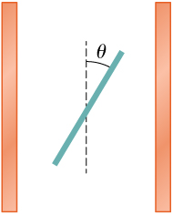

Solution

a. 

b. 

1. The infinite slab between the planes defined by  and  contains a uniform volume charge density  (see below). What is the electric field produced by this charge distribution, both inside and outside the distribution?

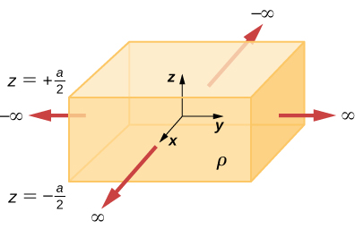

Solution

Construct a Gaussian cylinder along the *z*-axis with cross-sectional area *A*.

,



1. A total charge *Q* is distributed uniformly throughout a spherical volume that is centered at  and has a radius *R*. Without disturbing the charge remaining, charge is removed from the spherical volume that is centered at (see below). Show that the electric field everywhere in the empty region is given by



where  is the displacement vector directed from 

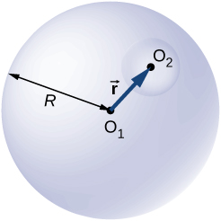

Solution

The electric field at an arbitrary point inside the sphere without the hole is . The actual distribution is a sphere of charge density  plus a hole of charge density . By superposition the electric field in the hole is .]

1. A non-conducting spherical shell of inner radius  and outer radius  is uniformly charged with charged density  inside another non-conducting spherical shell of inner radius  and outer radius  that is also uniformly charged with charge density . See below. Find the electric ﬁeld at space point *P* at a distance *r* from the common center such that (a) , (b) , (c) , (d) , and (e) .

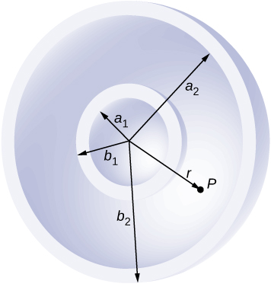

Solution

a. ;

b. ;

c. ;

d. ; e. 0

1. Two non-conducting spheres of radii  and  are uniformly charged with charge densities  and  respectively. They are separated at center-to-center distance *a* (see below). Find the electric ﬁeld at point *P* located at a distance *r* from the center of sphere 1 and is in the direction ** from the line joining the two spheres assuming their charge densities are not affected by the presence of the other sphere. (*Hint:* Work one sphere at a time and use the superposition principle.)

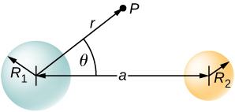

Solution

The electric field at *P* is equal to the vector sum of the electric fields from the two charges. Put the origin at the center of sphere 1.

*P* outside both spheres: ;

*P* inside sphere 1: ;

*P* inside sphere 2: 

1. A disk of radius *R* is cut in a non-conducting large plate that is uniformly charged with charge density ** (coulomb per square meter). See below. Find the electric ﬁeld at a height *h* above the center of the disk. (**). (*Hint:* Fill the hole with **.)

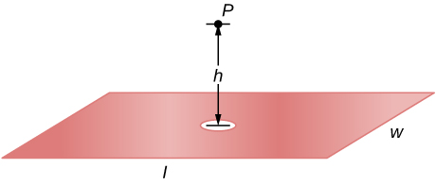

Solution

Electric field due to plate without hole: .

Electric field of just hole filled with .

Thus, .

1. Concentric conducting spherical shells carry charges *Q* and –*Q*, respectively (see below). The inner shell has negligible thickness. Determine the electric field for (a)  (b)  (c)  and (d) 

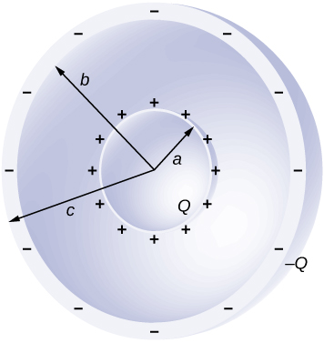

Solution

a. ; b. ; c. ; d.  since *q* enclosed equals 0

1. Shown below are two concentric conducting spherical shells of radii  and , each of finite thickness much less than either radius. The inner and outer shell carry net charges  and  respectively, where both  and  are positive. What is the electric field for (a)  (b)  and (c)  (d) What is the net charge on the inner surface of the inner shell, the outer surface of the inner shell, the inner surface of the outer shell, and the outer surface of the outer shell?



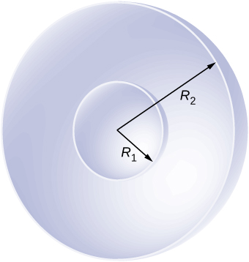

Solution

a. ; b. ; c. ; d. 

1. A point charge of  is placed at the center of an uncharged spherical conducting shell of inner radius 6.0 cm and outer radius 9.0 cm. Find the electric field at (a) , (b) **, and (c) . (d) What are the charges induced on the inner and outer surfaces of the shell?

Solution

a. ; b. ;

c. ; d. 

**Challenge Problems**

1. The Hubble Space Telescope can measure the energy flux from distant objects such as supernovae and stars. Scientists then use this data to calculate the energy emitted by that object. Choose an interstellar object which scientists have observed the flux at the Hubble with (for example, Vega[1]), find the distance to that object and the size of Hubble’s primary mirror, and calculate the total energy flux. (*Hint:* The Hubble intercepts only a small part of the total flux.)

Solution

Given the referenced link, using a distance to Vega of m and a diameter of 2.4 m for the primary mirror, we find that at a wavelength of 555.6 nm, Vega is emitting  at that wavelength. Note that the flux through the mirror is essentially constant.

1. Re-derive Gauss’s law for the gravitational field, with  directed positively outward.

Solution

Let a mass *M* be enclosed by a spherical surface of radius *R*: where *M* is the total mass inside *S*, *G* is Newton’s constant, and the unit normal is in the direction of .

1. An infinite plate sheet of charge of surface charge density  is shown below. What is the electric field at a distance *x* from the sheet? Compare the result of this calculation with that of worked out in the text.

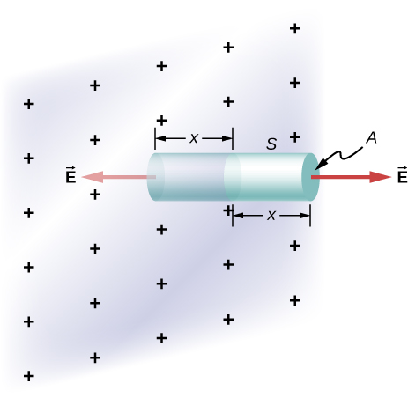

Solution

The symmetry of the system forces  to be perpendicular to the sheet and constant over any plane parallel to the sheet. To calculate the electric field, we choose the cylindrical Gaussian surface shown. The cross-section area and the height of the cylinder are *A* and 2*x*, respectively, and the cylinder is positioned so that it is bisected by the plane sheet. Since *E* is perpendicular to each end and parallel to the side of the cylinder, we have *EA* as the flux through each end and there is no flux through the side. The charge enclosed by the cylinder is  so from Gauss’s law,  and the electric field of an infinite sheet of charge is

 in agreement with the calculation of in the text.

1. A spherical rubber balloon carries a total charge *Q* distributed uniformly over its surface. At , the radius of the balloon is *R*. The balloon is then slowly inflated until its radius reaches 2*R* at the time  Determine the electric field due to this charge as a function of time (a) at the surface of the balloon, (b) at the surface of radius *R*, and (c) at the surface of radius 2*R*. Ignore any effect on the electric field due to the material of the balloon and assume that the radius increases uniformly with time.

Solution

a. , ; b. zero, since ;

c. 

1. Find the electric ﬁeld of a large conducting plate containing a net charge *q*. Let *A* be area of one side of the plate and *h* the thickness of the plate (see below). The charge on the metal plate will distribute mostly on the two planar sides and very little on the edges if the plate is thin.

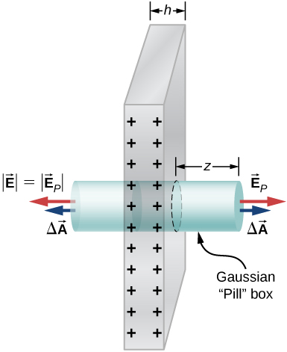

Solution

There is *Q*/2 on each side of the plate since the net charge is *Q*: ,



This file is copyright 2016, Rice University. All Rights Reserved.

1. http://adsabs.harvard.edu/abs/2004AJ....127.3508B